Bug 1: Test Output

# Game does not pay out at correct level

Specifically if a user wins on 1 match the balance does not increase.

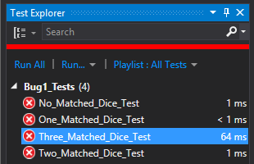

Test Name: No_Matched_Dice_Test

Test Outcome: True

Result Message: Assert.AreEqual failed. Expected:<-5>. Actual:<-5>.

Result StandardOutput: there were 0 matches

Test Name: One_Matched_Dice_Test

Test Outcome: Failed

Result Message: Assert.AreEqual failed. Expected:<10>. Actual:<5>.

Result StandardOutput: there were 1 matches

Test Name: Two_Matched_Dice_Test

Test Outcome: Failed

Result Message: Assert.AreEqual failed. Expected:<15>. Actual:<10>.

Result StandardOutput: there were 2 matches

Test Name: Three_Matched_Dice_Test

Test Outcome: Failed

Result Message: Assert.AreEqual failed. Expected:<20>. Actual:<15>.

Result StandardOutput: there were 3 matches